A quantitate analysis of string searching algorithms
Rastgar, Omer ali
June, 2020

Abstract
Our main focus would be on Rabin Karp and a custom algorithm that is optimized for the particular problem we are focusing on. The analysis determines if the custom algorithm can search keywords in a large database faster than Rabin karp algorithm. Our objective is to illustrate all research and analysis done while comparing these two algorithm and provide an unbiased selection of the most efficient algorithm to solve this problem.

- Introduction
Rabin Karp is a general pattern searching algorithm that uses hashing function along with naïve searching techniques to traverse a give string to locate a given pattern. In order to make an unbiased decision we will be first optimizing Rabin karp for this particular problem hence making sure we focus on the aims of time complexity over any other conditions as even though the overall efficiency may be compromised the algorithm would be serving it purpose of searching faster. This is why we have assumed that we have unlimited space.
In order to effectively compare these algorithms, we will have a control. This is the original Rabin karp algorithm [1] that would not be altered in any way. Hence will have a benchmark that both algorithm need to be a head of.
- Why select Rabin Karp?
Firstly, it is a fact that there are many algorithms that are better in performance with large databases. The reason I selected Rabin karp is it has many similarities with the design of my algorithm. My implementation was to design the best possible algorithm for this problem and I have taken elements from many different algorithms.

- Defining the problem set.

- Components of My algorithm
- make_lst(st):
- make_hashtable(sentences):
- fuzzy_word(word):
- get_index(string,prime):
- find_prime(n):
- search(word,lst):
- get_keywords(string,lst,sentences):

Note: The disadvantages mentioned below do not affect the problem that we are trying to solve rather they illuminate the faults that can occur if this algorithm is used for other general purposed ideas.
Pro & cons
- Stop word removal: there are no disadvantages of removing very common words such as “The”, “For”. These can never be keywords that people will search
- Removal of common words in group: Although this is needed in our problem, but this is not useful in problems such as searching words in books as we need to search all words and some might not be present.
- Soundex Algorithm: this helps in grouping common words in to one words for example searching for “decide” or “decided” will have same hash. The common benefit is that it can find words even if they are misspelled. Disadvantage is that It groups common sounding words like “feather” and “father”, although these two words sound different the problem is that feather can go to father by removing e. this algorithm works by removing vowels thus not a good solution for similar words searching.

- Changes made to Rabin Karp
In order to optimize the time there were changes made to Rabin karp these changes do increase space complexity but reduce time complexity. Also the original Rabin karp cannot find which group the word is present in, if we want to alter the original Rabin karp it would just increase time complexity even further thus a better version was made to combat that problem. The changes made are listed below.
- Word traversal: the original algorithm used naïve search to traverse over each character. Since we are using list we can traverse over words and remove words that are not important.
- Soundex algorithm: Although this decreased time complexity in the custom algorithm by grouping similar words. But in this algorithm it only provides a way to find misspelled words.
- Search more than one keyword: Since the problem requires us to search more than one keywords this step is necessary even if it is increasing the overall time.
- Show complete sentence group of word: this step also increases time but is necessary as we require complete sentences that have that particular word.

- Methods for Analysis
Theoretical
- Deductive reasoning:

- Mathematical proofs:
Time Complexity Libraries
We will be using the Profile library [2] and Time It library [3].
Python profiler was used to see the efficiency of the code as well as to isolate any hotspots.
Time It was used to accurately measure time taken for each algorithm to run. It was analyzed through 10000 cycles.
- Result
Profile Library
- My algorithm:
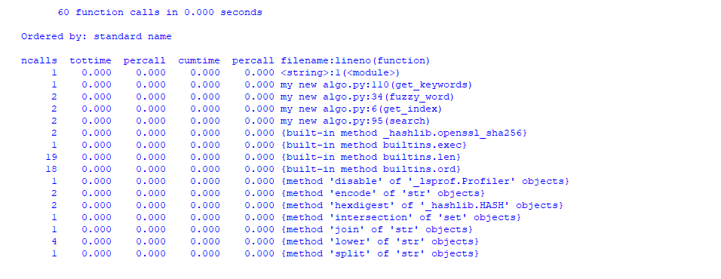
- Rabin karp algorithm:
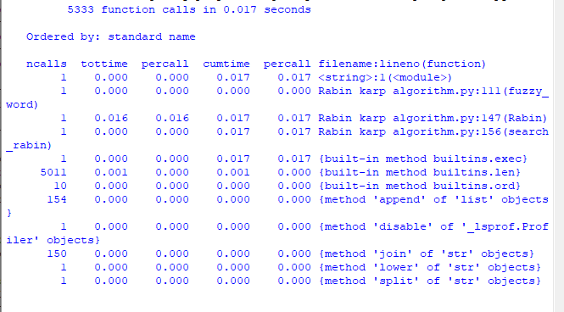
- Orignal Rabin Karp algorithim
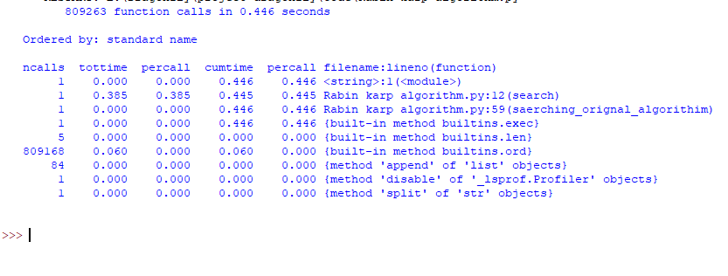

- Conclusion

Bibliography

0.33561533574999997 sec -> original
0.03997696059 sec -> rabin karp
1.595430000000002e-05 -> my algorithim

